**Supplementary Material S3. L+R- (strain 517) physiological properties as a function of initial L-arginine concentration.** Planktonic physiological data for L+R- grown in M9 medium containing 5 g L-1 lactose supplemented with varying concentrations of L-arginine. Data is the mean of three biological samples. cdw = cell dry weight, N.A.L. not arginine limited. Arginine was assumed to have been completely consumed in the 0.01 mM and 0.1 mM case. Arginine depletion was measured using NMR for the 1 mM case.

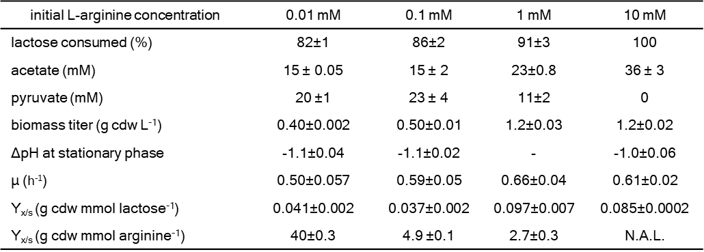

**Physiological data for L-R+ strain 515 grown planktonically in M9 media supplemented with varying concentrations of acetate and pyruvate.** Data is a mean of three biological samples while error bars are the standard error.